Cordial, Nicholas

Bevins, Lucas

Frost, Larry

CSC 340  Fall Semester 2023

FINAL REPORT

**I. Introduction 1**

**A. Problem Statement 1**

**B. Proposal 1**

**II. System Description 1**

**III. System Requirements 2**

**A. Functional Requirements 2**

**B. Non-functional Requirements 14**

**IV. Use Case Diagram 15**

**V. Class Diagram 16**

**VI. Sequence Diagrams 16**

**VII. Activity Diagrams 16**

**VIII. State Diagrams 16**

**IX. Database Design 16**

**X. Domain Diagram 17**

**XI. Conclusion 17**

# Introduction

## Problem Statement

ZZZ Pizza needs a system for their employees to edit and track the status of outgoing orders, as well as keep track of the status of their stock and business volume.

## Proposal

We propose a software system to help the store with order statuses and the management of stock items.

# System Description

The system includes three subsystems: an online ordering subsystem, an order management subsystem, and a stock management subsystem. The online ordering subsystem allows customers to order pizzas online. The orders shall be kept in a database. The staff of the store can then handle the orders with the order management subsystems. The status of an order should be kept in the database. The employees should be able to trace a customer’s orders online. The stock management system is for managing the stock of raw materials and sauces by allowing the manager to check the status of the stock and edit it to match when new stock arrives or when stock is used. If the status of the stock is low, the manager can then issue a low stock warning to let staff know they will need to watch their stock usage before putting an order in for more supplies from one of their suppliers.

# System Requirements

## Functional Requirements

1. The system shall allow an employee to check the status of an order.
   1. The employee shall login to their account.
   2. The system shall display current orders that are not completed along with the “Change Order Status” button.

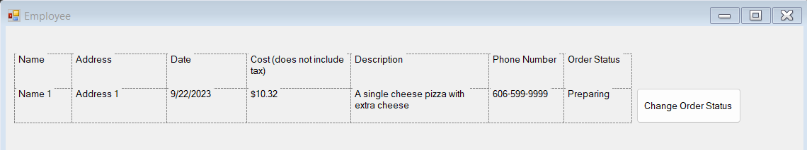

1. The system shall allow an employee to change the status of an order.
   1. The employee shall press the “Change Order Status” button.
   2. The system shall display the information of the order and the new order status.

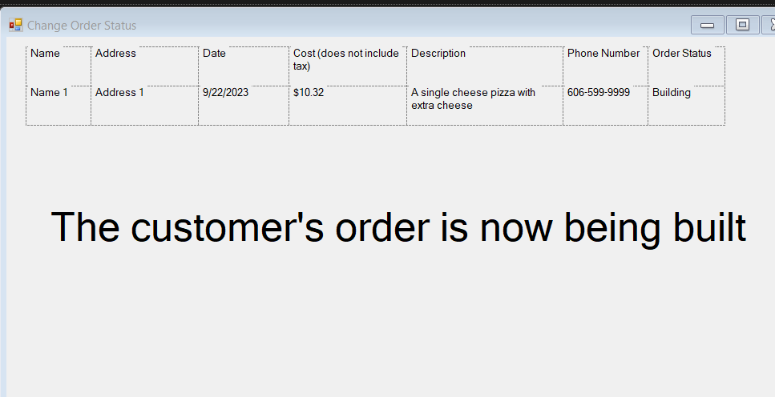

1. The system shall allow an employee to search for a customer’s profile.

3.1 The employee shall enter the name of the customer they want to search in a textbox.

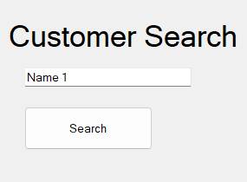

3.2 The employees shall press the “Search” button.

3.3 The system shall display every address, phone number and email associated with the name entered in the textbox as well as the name of the customer and the customer’s order history including the date, cost, and description of their orders.

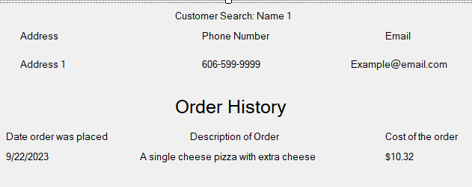

1. The system shall allow a manager to check the business volume by a specific day or month.
   1. The manager shall press the “Check Business Volume” button.
   2. The system shall display the check business volume form.
   3. The manager will choose a method for checking the business volume.
      1. If the manager wants to check by a month, they shall click the “Check by Month” button.
      2. The system shall display the form that contains the monthly business volume for the given month.

* + 1. If the manager wants to check by a specific day, they shall type the day, month, and year into the text box and click the “Check By Date” button.
    2. The system shall display the form that contains the daily business volume for the given date.

* 1. The manager shall press the return button to go back to the main menu.
  2. Go to R6.

1. The system shall allow an employee to edit the amount of stock the company has.
   1. The employee shall press the “Check Stock” button.
   2. The system shall display the company’s stock menu.

* 1. The employee shall press the “Edit” button.
  2. The system shall allow the employee to edit the stock values.

* 1. The employee shall press the “Save” button.
  2. The system shall save the stock changes to the database.

* 1. The employee shall press the “Return” button to go back to the main menu.
  2. Go to R8.

1. The system shall allow an employee to check the status of the stock and issue a low stock warning when needed.
   1. The employee shall press the “Check Stock” button.
   2. The system shall display the stock status form.

* 1. The manager shall press the “Issue Low Stock Warning” if they need to issue a warning.
  2. The system shall display a low stock warning.

* 1. The manager shall press the “Return” button to go back to the menu.
  2. Go to R7.

1. The system shall allow an employee to search for a supplier’s profile, and then edit said profile.
   1. The manager shall press the “Check Supplier Profile” button.
   2. The system shall display a supplier options page.

* 1. The manager shall input the name of the supplier they are looking for.
  2. The system shall display the supplier’s ID in the bar below.

* 1. The manager shall press the return button to go back to the main menu.
  2. If the manager wishes to edit the supplier information, they shall press the “Edit Supplier” button.
  3. The system shall allow the manager to edit the supplier information.

* 1. The manager shall press the save button.
  2. The system shall update the database with the updated information.
  3. The manager shall press the return button to go back to the main menu.
  4. Go to R8.

1. The system shall allow the manager to change the stock volume.
   1. The manager shall press the “Check Supplier Profile” button.
   2. The system shall display the supplier options page.
   3. The manager shall press the “Edit Stock Volume” button.
   4. The system shall display the stock volumes for the different stock options.

* 1. The manger shall change the options and press the save button.
  2. The system shall update the database with the updated information.
  3. The manager shall press the “Return” button to go back to the supplier options page.

## Non-functional Requirements

1. The system shall be capable of processing many orders at the same time.
2. The system shall be capable of updating many orders at the same time.

# Use Case Diagram

There are ten use cases defined for the system.

* Check Order Status will allow an employee to check the status of an order placed by a customer.
* Change Order Status will allow an employee to edit the status of an order as it goes through, from cooking to out for delivery to delivered.
* Search Customer Profile will allow an employee to search for the profile of a specified customer using their email/username.
* Check Supplier Profile will allow an employee to check the profile of a specified supplier by their name.
* Edit Stock will allow an employee to update the database with the status of the stock as they use their stock of items/sauces.
* List Stock will allow an employee to list the total amount of stock they have.
* Issue Low Stock Warning will allow an employee to issue a warning when their stock has reached a low level and needs to be replenished.
* Check Business Vol will allow a manager to check the business volume for a specific day or month and list the revenue earned.
* Edit Supplier Profile will allow a supplier to edit their profile.
* Change stock volume will allow a supplier to edit the volume of the stock they supply to the store.

# Class Diagram

# Sequence Diagrams

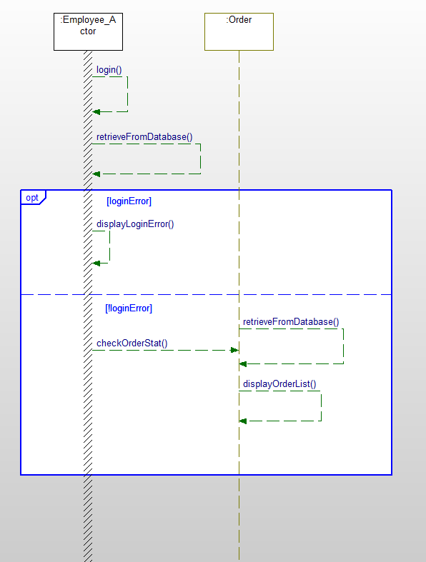

*The sequence diagram for the Check Order Status functional requirement.*

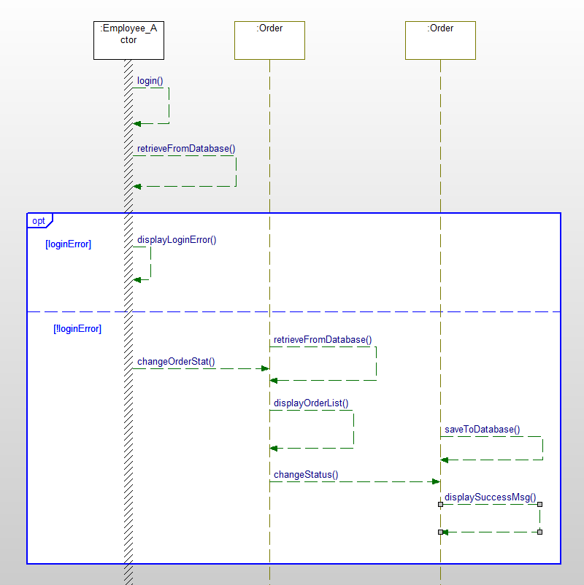

*The sequence diagram for the Change Order Status functional requirement.*

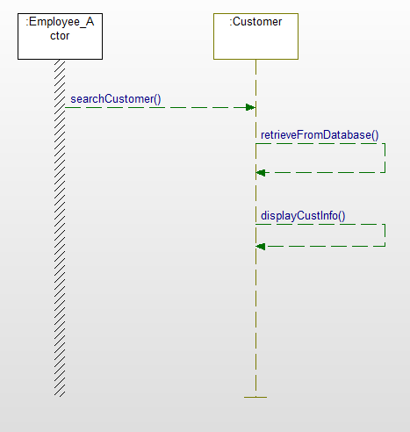

*The sequence diagram for the Check Customer Profile functional requirement.*

*The sequence diagram for the Check Supplier Profile functional requirement.*

*The sequence diagram for the Edit Stock functional requirement.*

*The sequence diagram for the List Stock and Issue Low Stock Warning functional requirement.*

*The sequence diagram for the Check Business Volume requirement.*

*The sequence diagram for the Edit Supplier Profile requirement.*

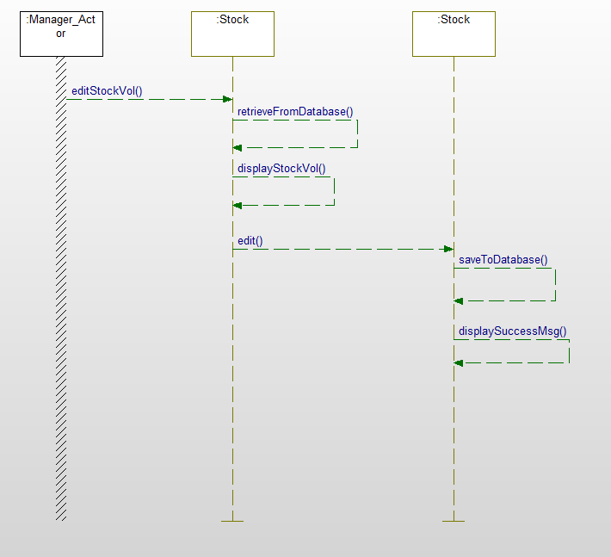

*The sequence diagram for the Change Stock Volume requirement.*

# Activity Diagrams

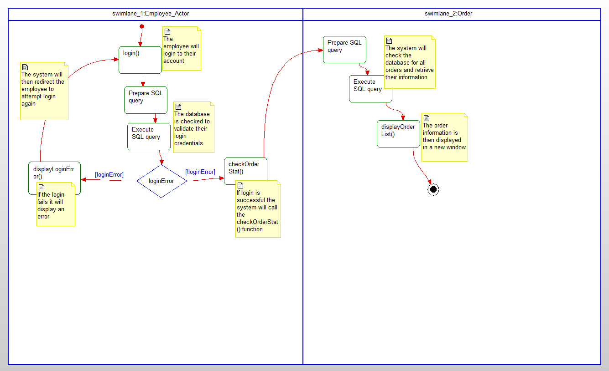

*The activity diagram for the Check Order Status functional requirement.*

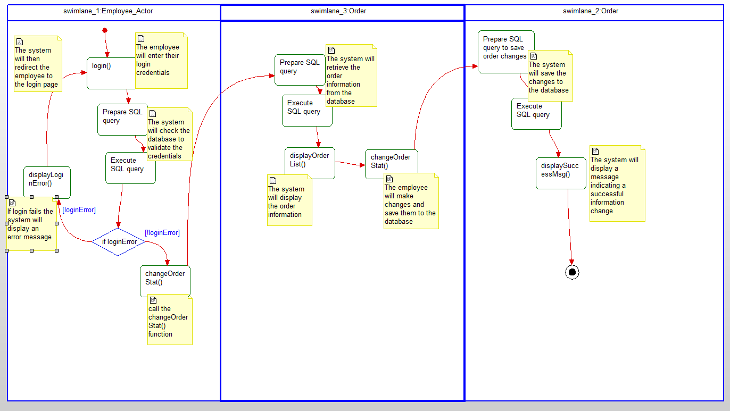

*The activity diagram for the Change Order Status functional requirement.*

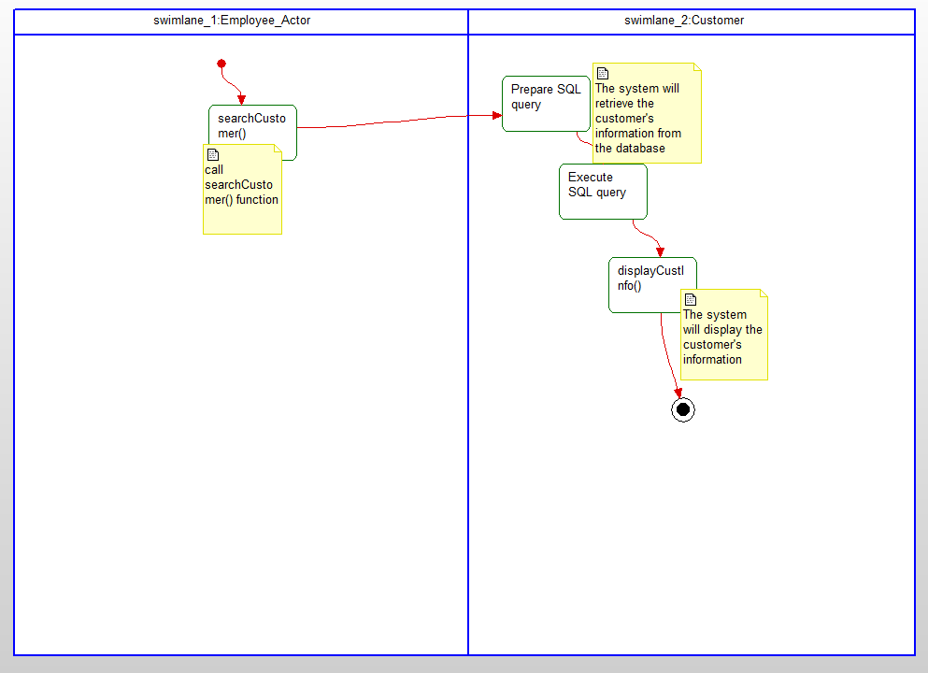

*The activity diagram for the Check Customer Profile functional requirement.*

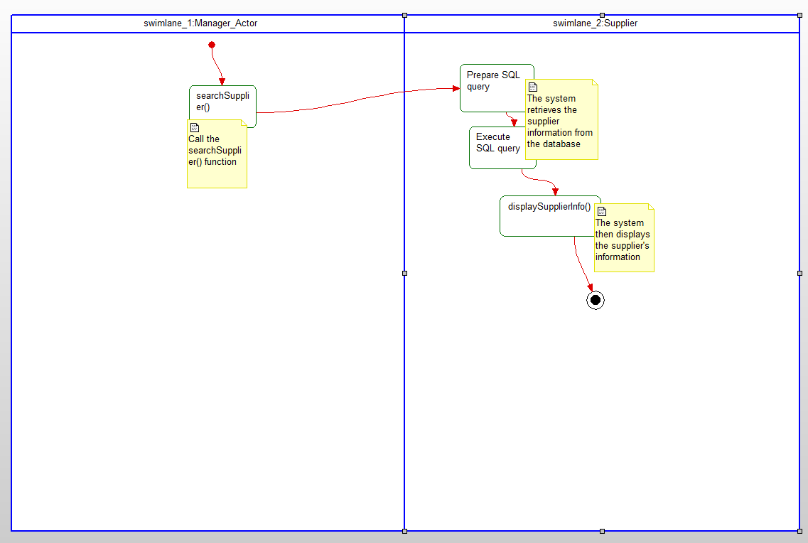

*The activity diagram for the Check Supplier Profile functional requirement.*

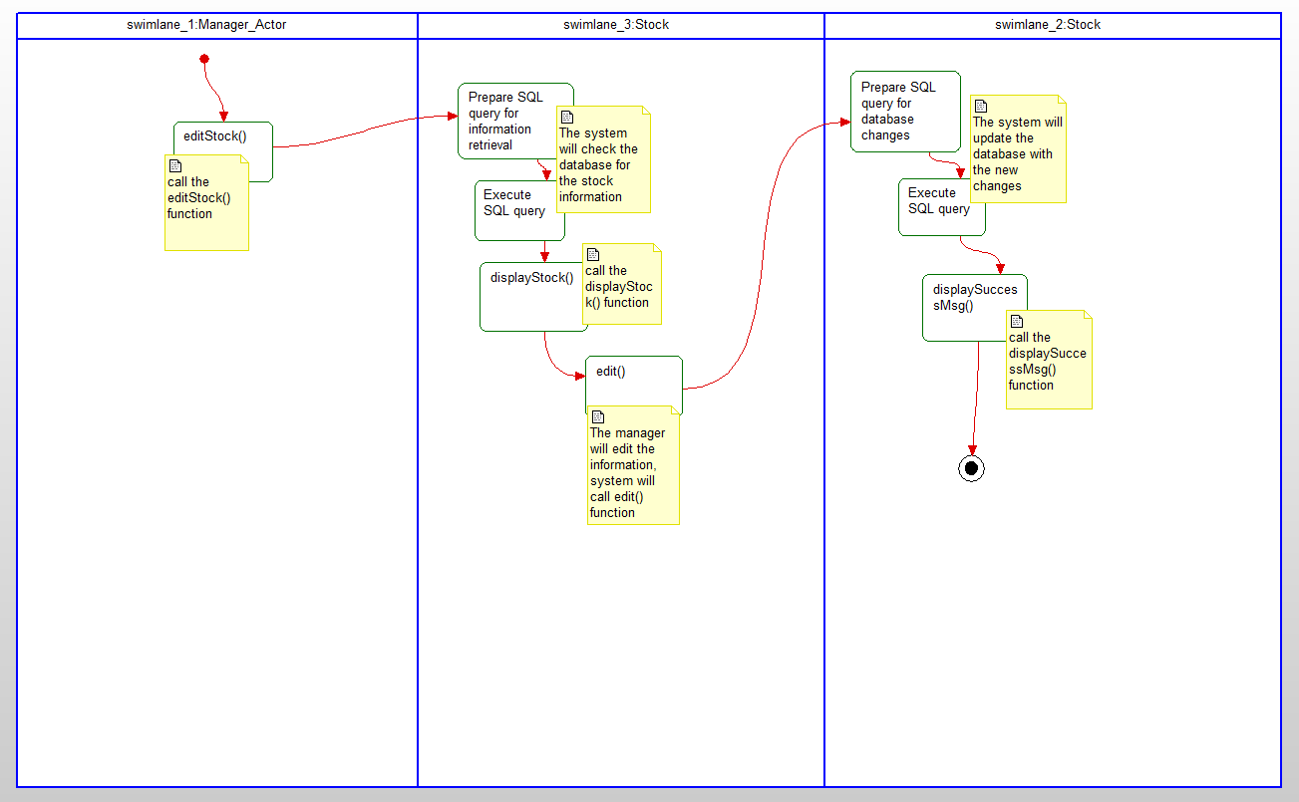

*The activity diagram for the Edit Stock functional requirement.*

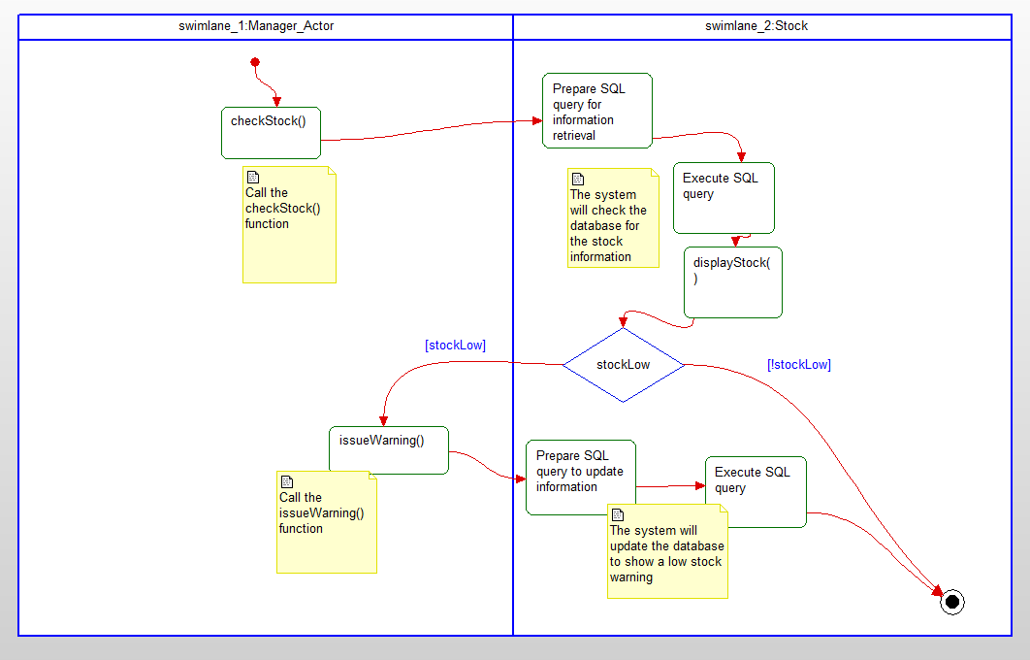

*The activity diagram for the Check Stock and Issue Low Stock Warning functional requirement.*

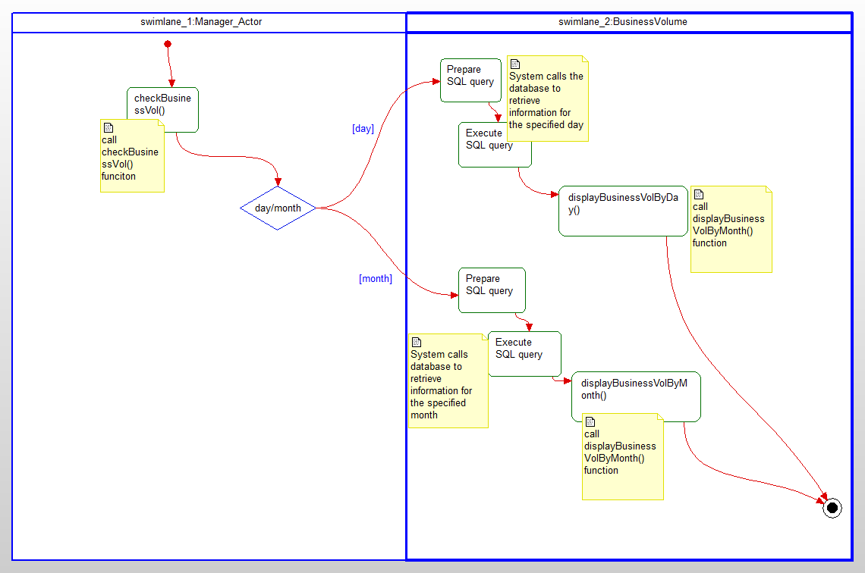

*The activity diagram for the Check Business Volume functional requirement.*

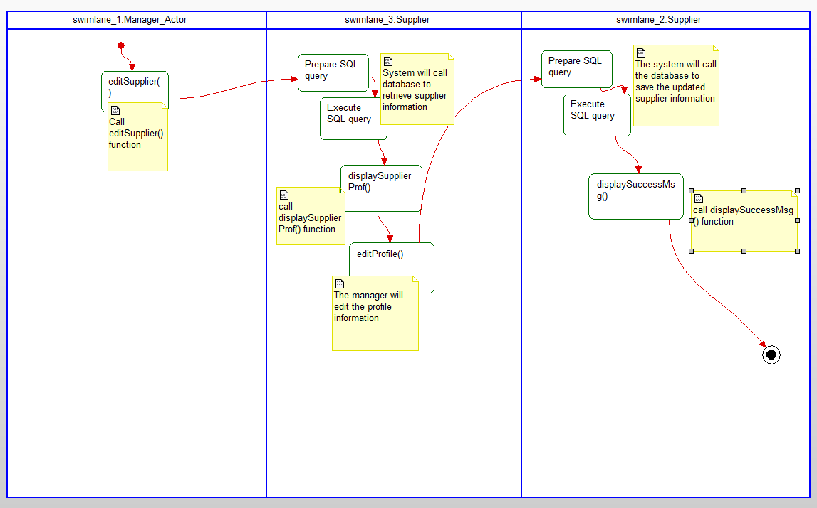

*The activity diagram for the Edit Supplier functional requirement.*

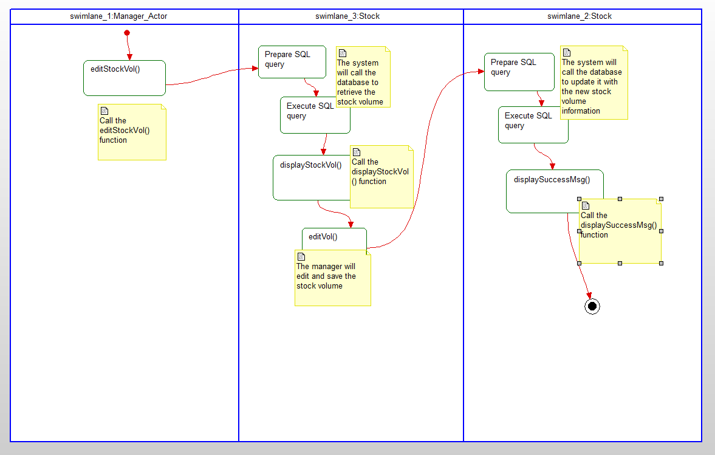

*The activity diagram for the Change Stock Volume functional requirement.*

# State Diagrams

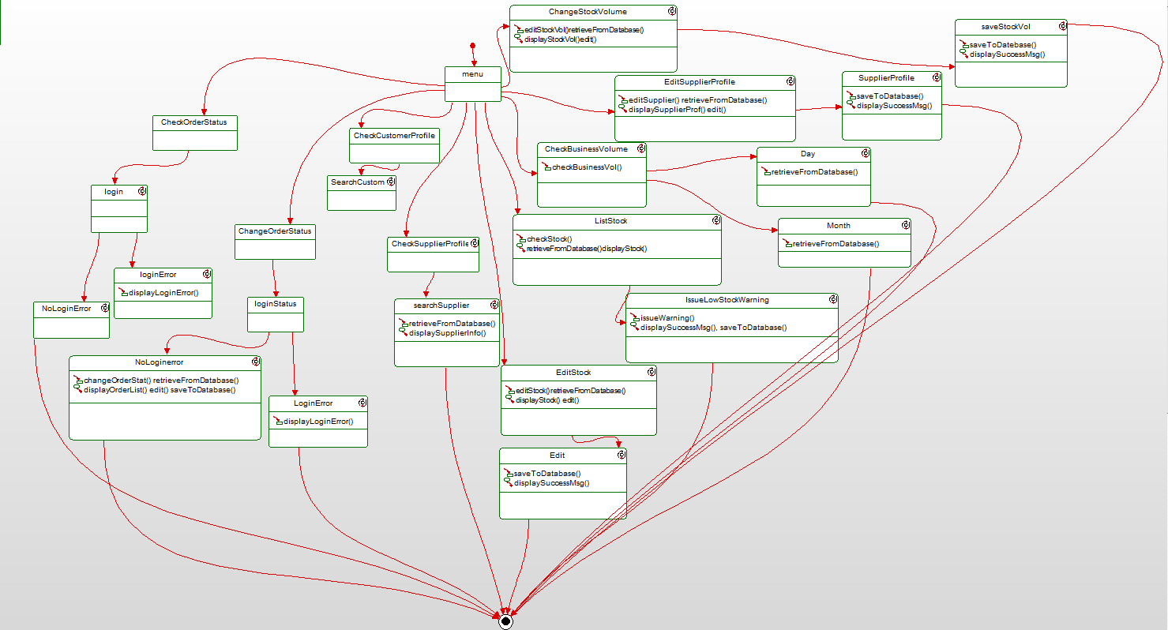

# Database Design

## ER Diagram

## Table Schema

# Conclusion

The system shall have twelve use cases consisting of check order status, change order status, check customer profile, check supplier profile, edit stock, list stock, issue low stock warning, check business volume , edit supplier profile, and change stock volume. Above we have listed the functional requirements needed in order to complete the development of the software, as well as some additional non-functional requirements that will be beneficial to the system and users. Pizza yum :)